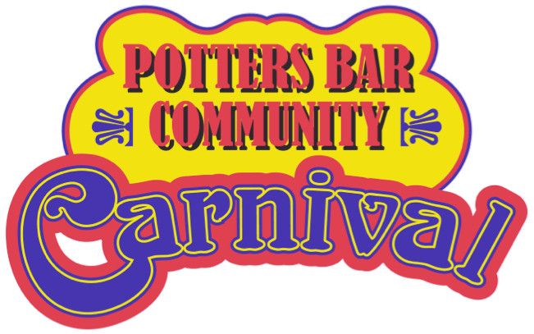 POTTERS BAR CARNIVAL
Sunday 12th June 2022
ELM COURT 363 MUTTON LANE
facebook.com/PottersBarCarnival
www.pottersbarcarnival.co.uk

Please reply to Terry Jones, 297 Mutton Lane, Potters Bar EN6 2AT Mobile 07507 646714 terry.jones2@sky.com

ENTRY TO CARNIVAL PROCESSION

Name of Organisation

Name of Contact

Address

Post Code ……………………… .email:……………..………………………………….……………..

Tel. ………………………………….. mobile:…………………………………..

WALKING Please Tick (from Mount Grace Road)

VEHICULAR Please Tick (from Canada Life Car Park)

OTHER Please Tick

Name of firm supplying transport (for reference only)

PLEASE ENSURE YOU HAVE PUBLIC LIABILITY INSURANCE TO COVER YOUR FLOAT FOR THE DURATION OF THE PROCESSION

Lantern who supply some of the lorries need copy of your Insurance before they will supply a lorry. They need this at least 4 weeks before the Carnival
Contact Jan 07946 795173 for info.

It would help us in our organisation to know how many people will be taking part in the procession from your organisation. Please give us your best estimate. Under 18 years …………Over 18 years………………..

ACKNOWLEDGEMENT WILL NOT BE SENT UNTIL 3-4 WEEKS PRIOR TO THE CARNIVAL

Signed

Position in Organisation ……………..Date

